## Chapter 5 Experiment 4

In Chapter 5 we will practicing how setup a interrupt handling system by using a piece of programmable interrupt controller 8259. We generate a interrupt request by pressing a spin button, and in the interrupt service routing, we will move the light of a lantern.

## Assignments

1. Simple interrupt handling systems .

In this experiment, a piece of 8259 is used to expand the hardware interrupt source of a 8088 processor from one to eight. In its interrupt request IR0, a spin button is connected. When we press the spin button, a high level input will generate a interrupt request. The PIT 8259 is set to be working single piece, normal EOI, level triggered, slave buffered mode, and the interrupt number for IR0 is 40H. As is shown in Figure 5.1 and Figure 5.2.

On the other side, a latch buffer chip 74LS373 is used to interface 8 led lights, and this unit is used as the output device of experiment.

You are required to do:

1. Program the PIC 8259;
2. Write a interrupt service routine (ISR), which is a far typed sub procedure. In the ISR, you are required to change display of the lantern, and move the light upward. If the light has already been the top led, then roll back to the bottom one;
3. Register the ISR to the operating system, and run your program with the hardware schematic design.

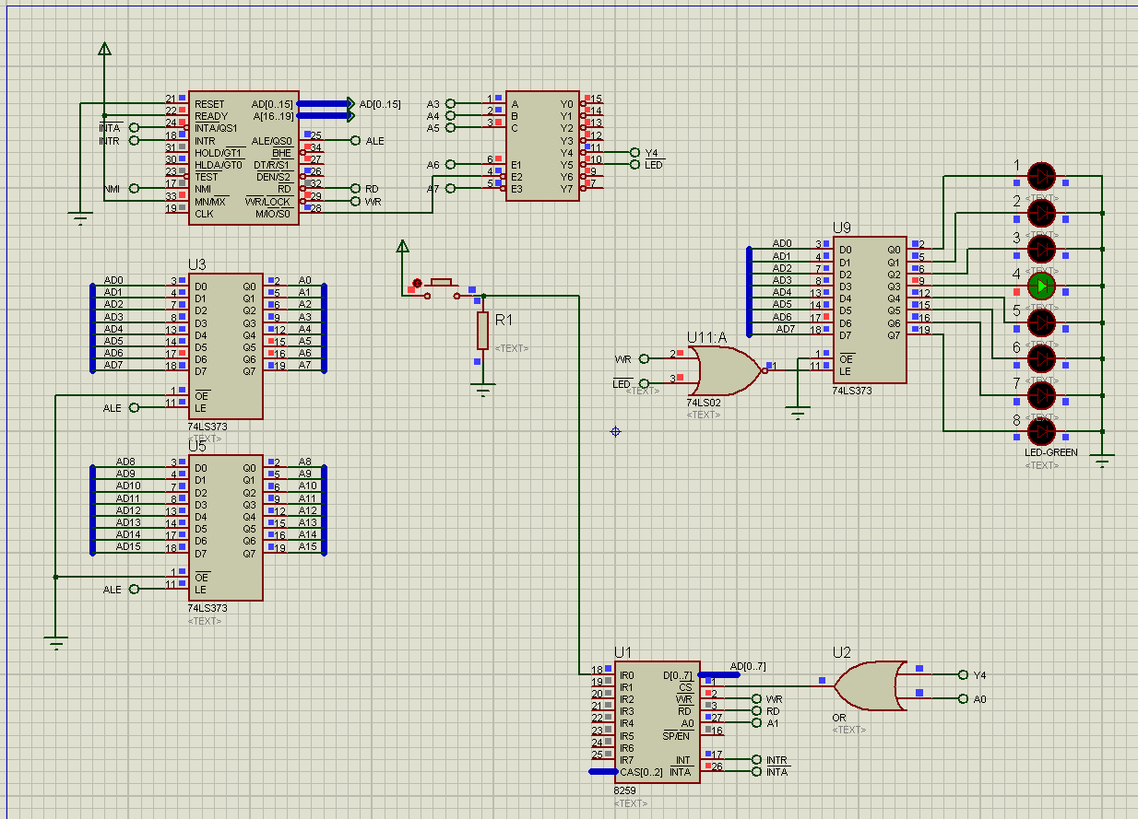

Figure5.1 The hardware schematic design

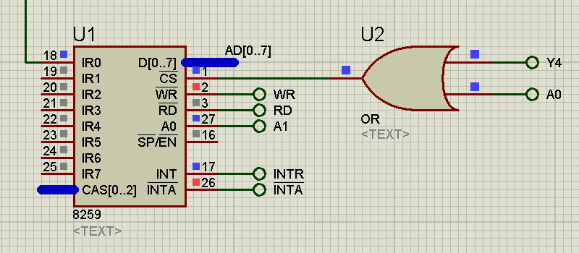

Figure5.2 The PIC 8259

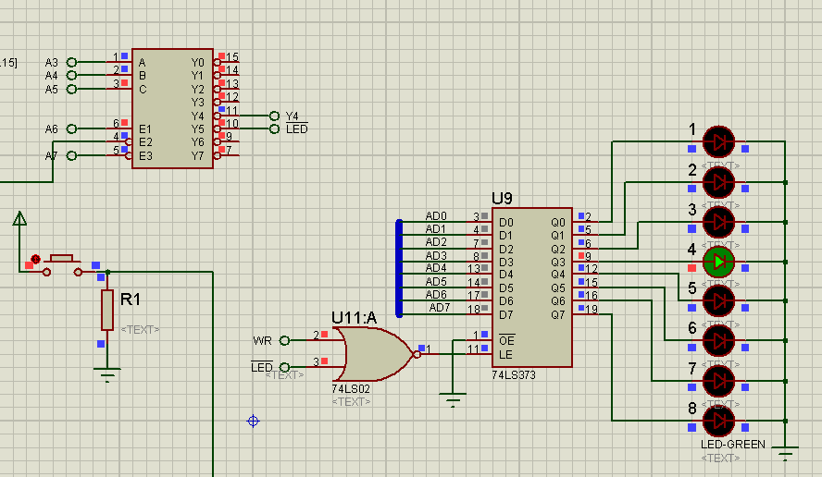

Figure5.3 Address decoder and lantern display unit

## Experiment Preparation

All the thing below should be prepared for experiment1:

1. The programs for assignment 1;
2. The VMWare Virtual Machine Windows XP with Emu8086 and Proteus installed.
3. Import hardware schematic design files into Windows XP virtual machine.

## Experiment Circuit Scheme

See figure 5.1, figure 5.2, and figure 5.3.

## Experiment Process

Start the the virtual machine Windows XP, and import all the programs of assignments.

Debug the program till it runs properly. 

Notice：

There is some bugs with the 8259 component of Proteus software. It will not response to the second round of INTA signal. Thus 8086 will not retrieve correct interrupt number from 8259.

As a result, we must ensure that when the 8086 is handling the interrupt request and try to retrieve interrupt number from 8259, the correct interrupt number appears in the data bus. We satisfied the requirement above by output the interrupt number 40H to a null port in a continuous loop, as is shown in Figure5.4

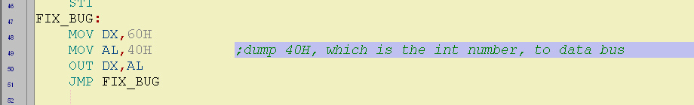

Figure 5.4 output interrupt number to the data bus